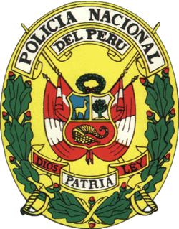

**NATIONAL POLICE OF PERU**

**CRIMINOLOGY DIRECTION**

**CRIMINAL DIVISION IDENTIFICATION**

**CERTIFICATE BACKGROUND RECORDS**

**(Expires in 90 days)**

IT´S CERTIFIED THAT THE PARTICIPANT:

WITH NATIONAL IDENTIFICATION NUMBER:

NO CRIMINAL RECORDS

VALID FOR NATIONAL AND INTERNATIONAL USE

Lima, July 19th of 2024

**GENERAL MANAGEMENT**

**JUDICIAL SYSTEM**