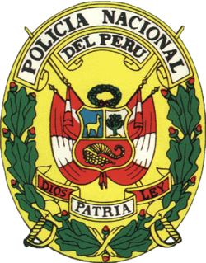

NATIONAL POLICE OF PERU
CRIMINOLOGY DIRECTION
CRIMINAL DIVISION IDENTIFICATION
CERTIFICATE BACKGROUND RECORDS
(Expires in 90 days)

IT´S CERTIFIED THAT THE PARTICIPANT: ANDREA FERNANDA ROBLES ANTICONA

WITH NATIONAL IDENTIFICATION NUMBER: 75959725

NO CRIMINAL RECORDS

VALID FOR NATIONAL AND INTERNATIONAL USE

Lima, June 10th of 2017

GENERAL MANAGEMENT
JUDICIAL SYSTEM

